**___________________**

**Predictive Maintenance of Engines**

Group Members:

PRIYANSHU PRASAD

CHANDRU S

SAKSHAM RATHI

PRIYANSHU BHATTACHARYA

Contents

**INTRODUCTION 3**

**OVERVIEW 3**

**PURPOSE 3**

**THEORETICAL ANALYSIS 4**

**BLOCK DIAGRAM 4**

**HARDWARE/SOFTWARE DESIGNING 5**

**EXPERIMENTAL INVESTIGATIONS 5**

**FLOWCHART 7**

**RESULT 8**

**ADVANTAGES AND DISADVANTAGES 9**

**Advantages: 9**

**Disadvantages: 10**

**APPLICATIONS 11**

**CONCLUSION AND FUTURE WORK 12**

**CONCLUSION: 12**

**APPENDIX 14**

**UI OUTPUT SCREENSHOT 15**

# **INTRODUCTION**

## OVERVIEW

Aircrafts are a very important part of the modern age. The number of passengers traveling by airplanes has been increasing every year (until Covid happened). In 2019, the number of scheduled passengers boarded by the global airline industry reached over 4.54 billion people. So the safety of aircraft passengers’ is of paramount importance.

It is crucial that Aircraft Engines should undergo proper maintenance. Doing routine maintenance can be very expensive. Predictive maintenance is an effective alternative to it. This approach ensures cost saving. It is also called condition-based maintenance, as the degrading state of an item is estimated to schedule maintenance. Machine Learning is widely used for predictive maintenance.

# **PURPOSE**

Engine failure is highly risky and needs a lot of time for repair. Unexpected failure leads to loss of money and time. Predicting the failure prior, will save time, effort, money and sometimes even lives. The failure can be detected by installing the sensors and keeping a track of the values. The failure detection and predictive maintenance can be for any device, out of which we will be dealing with the engine failure for a threshold number of days.

The problem can be posed as a regression or binary classification or multi-class classification for this dataset. In our case, binary classification is done and the code predicts whether the Engine will fail in the next 30 cycles or not. Class label 1 represents that it will fail in the next 30 cycles and class label 0 represents that it won’t. These labels are not given by dataset but are generated by code.

# **THEORETICAL ANALYSIS**

## **BLOCK DIAGRAM**

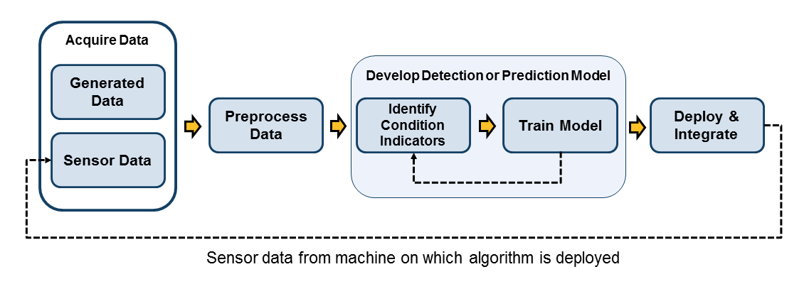

# **HARDWARE/SOFTWARE DESIGNING**

We have used python programming language to write the code on jupyter notebook which is a server-client application that allows editing and running notebook documents via a web browser. The Jupyter Notebook App can be executed on a local desktop requiring no internet access or can be installed on a remote server and accessed through the internet.

The train set consists of run-to-failure data of 100 Aircraft Engines. The test set consists of operating data of 100 aircraft engines without failure events recorded. And the RUL files hold the record of remaining cycles for each engine in the test set. The dataset has four different sets of these files simulated under different combinations of operational conditions and fault modes.

# **EXPERIMENTAL INVESTIGATIONS**

The implicit assumption of modeling data as done by us is that the asset of interest has a progressing degradation pattern, which is reflected in the asset's sensor measurements. By examining the asset's sensor values over time, the machine learning algorithm can learn the relationship between the sensor values and changes in sensor values to the historical failures in order to predict failures in the future.

Our model takes three datasets as inputs-

**Training data**: It is the aircraft engine run-to-failure data.

**Testing data**: It is the aircraft engine operating data without failure events recorded.

**Ground truth data**: It contains the information of true remaining cycles for each engine in the testing data.

All the datasets are in text form, hence we converted them into CSV form for better understandability of the dataset.

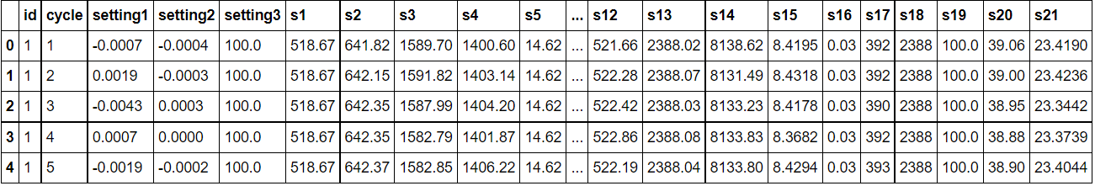

The training data consists of multiple multivariate time series with "cycle" as the time unit, together with 21 sensor readings for each cycle. Each time series can be assumed as being generated from a different engine of the same type. Each engine is assumed to start with different degrees of initial wear and manufacturing variation, and this information is unknown to the user. In this simulated data, the engine is assumed to be operating normally at the start of each time series. It starts to degrade at some point during the series of the operating cycles. The degradation progresses and grows in magnitude. When a predefined threshold is reached, then the engine is considered unsafe for further operation. In other words, the last cycle in each time series can be considered as the failure point of the corresponding engine.

The testing data has the same data schema as the training data. The only difference is that the data does not indicate when the failure occurs (in other words, the last time period does NOT represent the failure point). Taking the sample testing data shown in the following table as an example, the engine with id=1 runs from cycle 1 through cycle 31. It is not shown how many more cycles this engine can last before it fails.

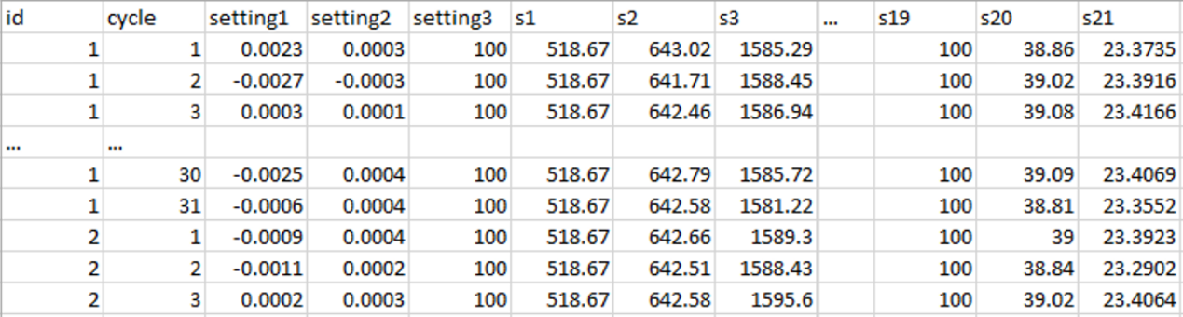

The ground truth data provides the number of remaining working cycles for the engines in the testing data.

# **FLOWCHART**

Step 1: Data preparation and feature engineering

Step 2: Train and evaluate model

Step 3: Deploy as web service using IBM Cloud

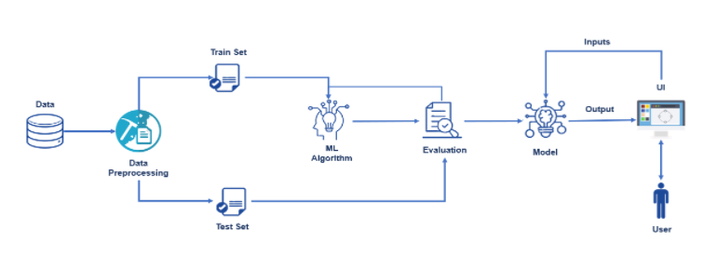

# **RESULT**

* We were able to load, pre-process, and normalize the data.
* We used logistic regression algorithm for building the model.
* We got an accuracy of 99% on the test data.
* We successfully deployed the model using IBM Cloud and created a web app for it.
* We gained domain knowledge of the engine maintenance field.

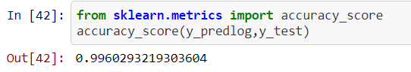

# **ADVANTAGES AND DISADVANTAGES**

## **Advantages**:

Some of the most prominent benefits of predictive maintenance are the following:

* Reduced downtime and longer life

Asset failures can be quite stressful and expensive. Predictive maintenance can predict issues, reducing downtime. A PWC report claims that PdM enhances uptime by 9% and extends the lifetime of aging assets by 20%.

* Reduced maintenance costs

Since planned maintenance is carried out based on a schedule, there might be instances when maintenance is carried out even when it is not required. Predictive maintenance eliminates such inefficiencies. From the symptoms interpreted from the data, technicians can focus on only the necessary equipment, saving costs and time.

* Improved safety

Predictive maintenance can help reduce workplace accidents by alerting the maintenance teams regarding any imminent equipment failures. According to PWC, predictive maintenance in manufacturing can reduce safety, health, and environmental risks by 14%.

* Enhanced productivity

If equipment breaks down during a critical operation, the entire workflow gets disrupted. Discontinuity in operations and the forthcoming repairs can take away valuable time and resources. By preventing any unprecedented equipment breakdowns, predictive maintenance ensures operational continuity and seamless workflows.

## **Disadvantages**:

Despite its vast set of advantages that provide a considerable impetus to some companies’ net throughput, predictive maintenance comes with its own challenges. A few of such challenges that make it unsuitable for some companies are:

* Scheduling takes time

It takes a considerable amount of time to plan and implement a PdM schedule.

* Additional costs

Given the complex nature of predictive maintenance, plant personnel needs to be trained on using the equipment and interpreting the analytics. It also involves investment in maintenance tools and systems. Tersely, condition monitoring has a high upfront cost.

# **APPLICATIONS**

Predictive maintenance can find application in all industries where machines produce significant amounts of data and where data analysis can support maintenance and fine-tuning. Mentioned below are some industries where PdM is already gaining prominence are the following:

* Automotive

In an industry that relies heavily on production and assembling, equipment failure can result in disruption and might incur the company millions. It is no surprise that the automotive industry will embrace PdM technology that reduces downtime and ensures continuous and efficient workflows.

* Transportation

Airlines have to consistently, closely monitor sensor data from the airplanes’ complex equipment. Proper functioning of equipment is of paramount importance to ensure passengers’ safety. Complex machinery present in trains can also benefit from predictive maintenance.

* Oil & Gas

The Oil & Gas industry utilizes costly equipment in extraction and refining processes that can lead to health and environmental hazards in case of failure.

* Ports

Since port equipment is continuously exposed to harsh conditions, their conditions deteriorate quickly. For example, cranes are crucial tools but are prone to failure. Crane downtime can lead to more waiting time for ships and lower throughput for ports. Reducing downtime can play a critical role in enhancing service quality and minimizing waste.

# **CONCLUSION AND FUTURE WORK**

## **CONCLUSION**:

Predictive maintenance presents you with the best time to work on an asset so that maintenance frequency is minimal and reliability is as high as possible while eliminating unnecessary costs. However, there are few disadvantages to predictive maintenance like high start-up costs and the need for specialized personnel.

Clearly, predictive maintenance is not apt for every company, especially those that have not yet implemented planned maintenance activities. However, larger organizations that have outgrown conventional maintenance practices and have additional budgets should leverage predictive maintenance. Predictive maintenance has been shown to result in a tenfold increase in ROI, 25%-30% reduction in maintenance costs, a 70%-75% decrease in breakdowns, and a 35%-45% reduction in downtime. These statistics are evidence of why predictive maintenance is gaining prominence quickly.

**FUTURE WORK**

* Reduce Overfitting
* Use LTSM and neural network for model building
* Build a more user friendly UI in the frontend

**BIBLIOGRAPHY**

1. **Azure Gallery**

* [**https://gallery.azure.ai/Experiment/Predictive-Maintenance-Step-1-of-3-data-preparation-and-feature-engineering-2**](https://gallery.azure.ai/Experiment/Predictive-Maintenance-Step-1-of-3-data-preparation-and-feature-engineering-2)
* [**https://gallery.azure.ai/Experiment/Predictive-Maintenance-Step-2A-of-3-train-and-evaluate-regression-models-2**](https://gallery.azure.ai/Experiment/Predictive-Maintenance-Step-2A-of-3-train-and-evaluate-regression-models-2)
* [**https://gallery.azure.ai/Experiment/Predictive-Maintenance-Step-3A-of-3-deploy-web-service-with-a-regression-model-2**](https://gallery.azure.ai/Experiment/Predictive-Maintenance-Step-3A-of-3-deploy-web-service-with-a-regression-model-2)

1. **Files and references provided by SmartInternz**

* <https://www.kaggle.com/behrad3d/nasa-cmaps>

# **APPENDIX**

**SOURCE CODE**

1. **Train.ipynb -** File in the GitHub Repository
2. **Index.html** and associated **style.css** file in repository
3. **App_cloud.py**

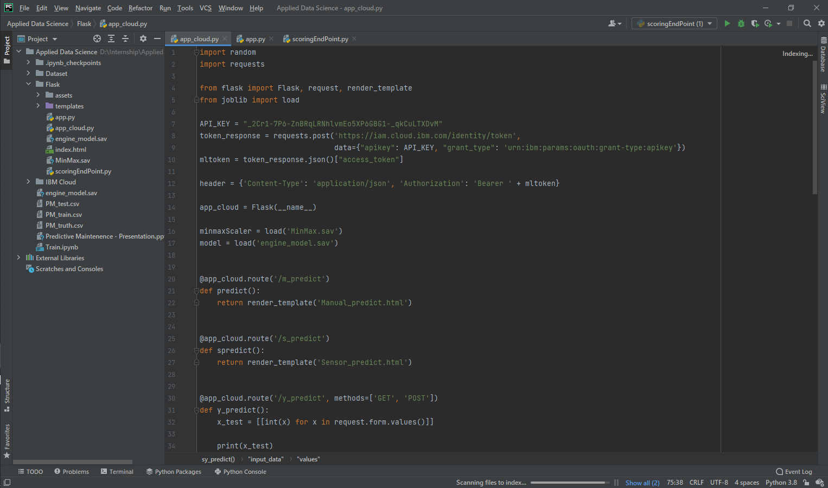

# **UI OUTPUT SCREENSHOT**

1. **Home Page**

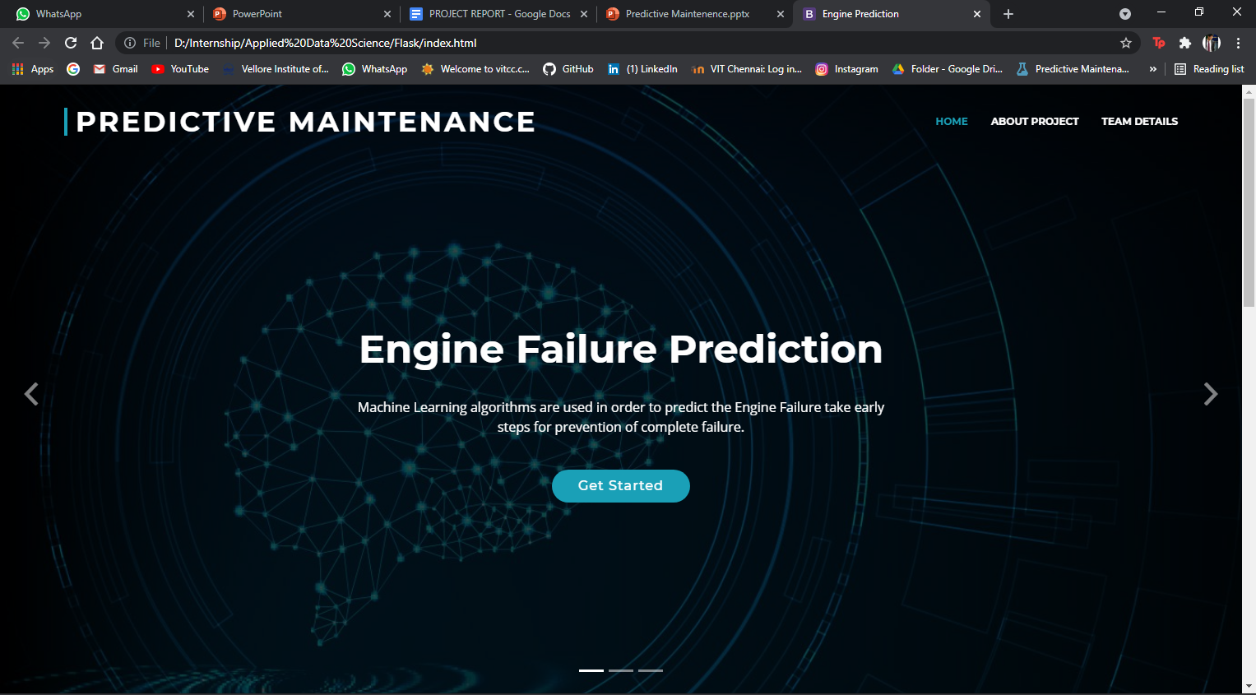

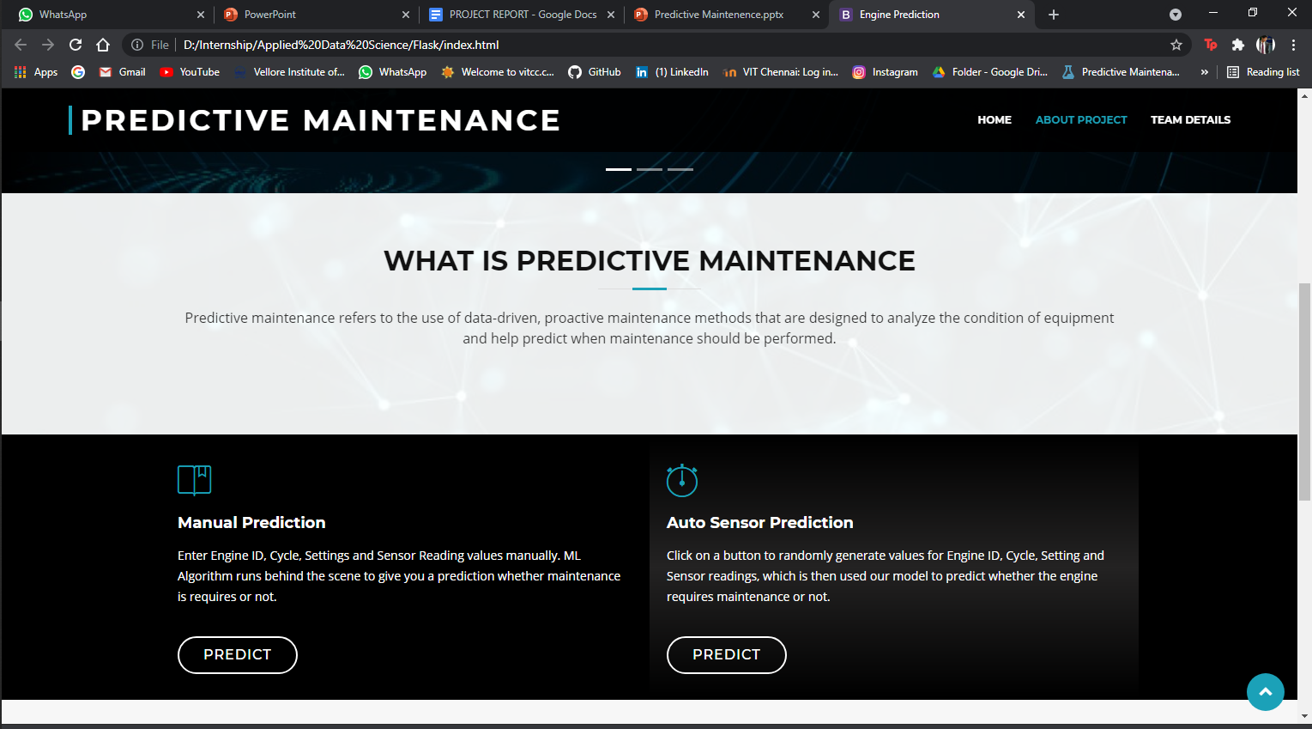

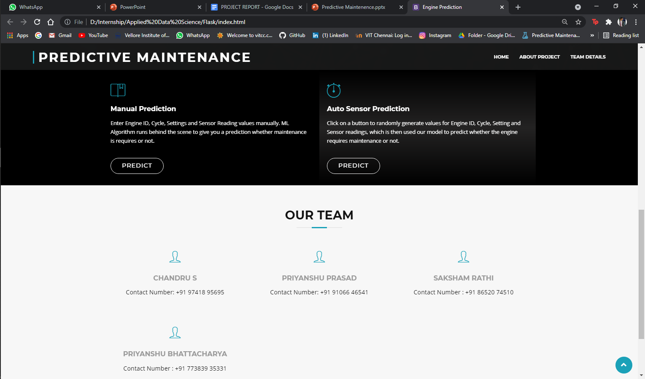

1. **Manual Prediction**

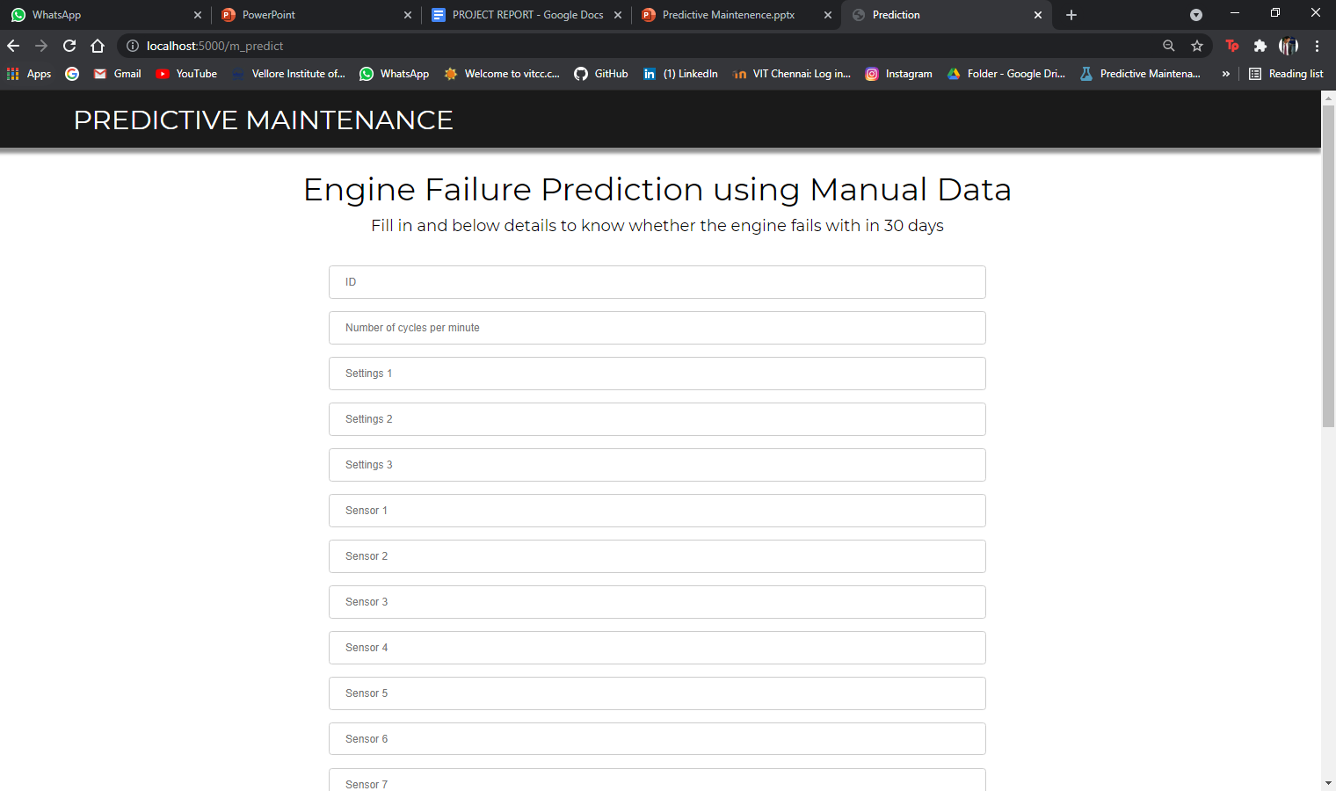

1. **Random - Prediction**

